Howa Miniaction .300 Blackout – More than just good fun!
by Dave Benfell
August 26, 2020
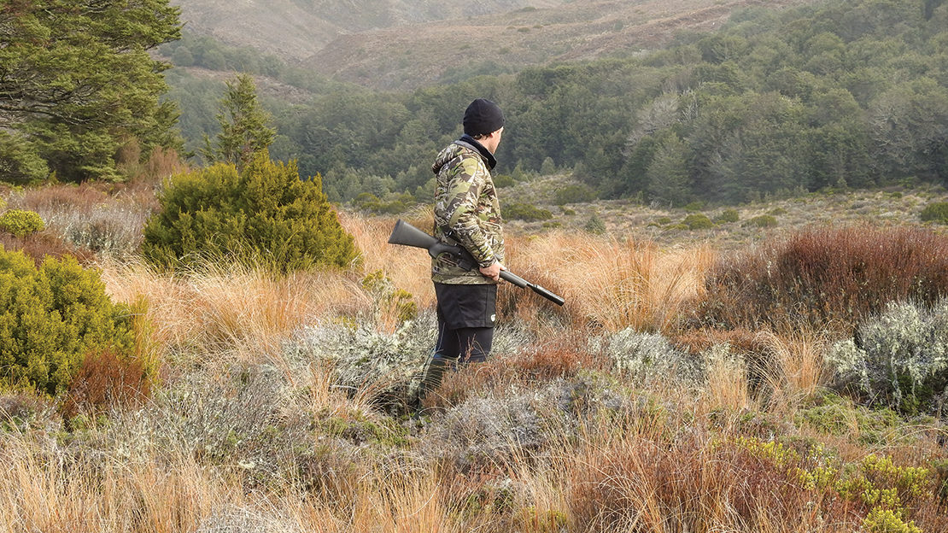
Howa is a Japanese company that’s been making military rifles and ammunition since 1932 and hunting rifles since 1959. It remains today a company capable of manufacturing a huge range of products and has, over its history, produced everything from hand grenades to textile machines. The Howa 1500 action first produced in 1979 is the standout action for Howa and has a reputation of being robust, very customisable, and well-made. The 1500 has many variations and has gone through a lot of tweaks since it was first introduced but remains a popular action and has many fans from the long-range shooting fraternity.

GENERAL DESCRIPTION
For this review we were supplied with a Howa MiniAction .300 Blackout (BLK) packaged with a Nikko Sterling Panamax 3-9×40 scope with a .300 Blackout reticle and a Sonic 40mm compact suppressor.
The Howa is a very lightweight rifle at 5.7lbs unscoped, has a free-floated 16.25-inch heavy contour barrel, Hogue stock, and comes pre-threaded for a suppressor. The Hogue stock has a straight comb and is pillar bedded.
The safety is a three-position design I’m a big fan of. Often with economy rifles, you get cost-cutting features like a standard two-position, however in terms of safety, you cannot beat a three-position. Being able to work the bolt with the safety set to ‘safe’ is a massive bonus to safe unloading procedure.
The trigger is adjustable from 2.5lbs to 3.8lbs and is a two-stage design, which you don’t see a lot of these days. A two-stage trigger requires a take up of an initial light pressure until you touch the final stage which requires the traditional weight of trigger pull to release a shot. Although it’s not a safety feature like the AccuTrigger, it feels similar in that you need to take up the initial pressure. Two-stage triggers are fantastic once you’ve dialled the required pressure in to muscle memory – shooters often speak of the accuracy gains.

.300 BLACKOUT
Originally developed as a military cartridge that could be used in standard M4 magazines and M4 bolts, the .300 Blackout (BLK) takes a different approach to effective small arms fire at standard contact ranges. Whereas the 5.56mm took the approach of small and fast, the .300 BLK is the opposite choosing big, slow, and heavy for its projectiles. The ballistics of the two approaches are fascinating, however the .300 wins in versatility stakes by being capable of firing subsonic ammunition; the heavier weighted projectiles also buck the wind better and retain downrange velocity. Although I’m not sure if this was a stipulation, I believe the .300 would have less pass-through potential in a target than some 5.56mm military grade ammunition. The effective ranges are surprisingly similar with the .300 being around 500m and the 5.56mm being 5-600m. Neither calibre is particularly spectacular out at those extended ranges, but from a military angle, volume of fire is a key component of effectiveness. From a hunting perspective, I believe the .300 BLK is effective on large game animals inside 200m, although I’m sure it could down animals at further – it’s just there are a hundred other calibres more suitable. All in all, the .300 is quiet, low recoiling, and fires subsonic ammunition with ease.
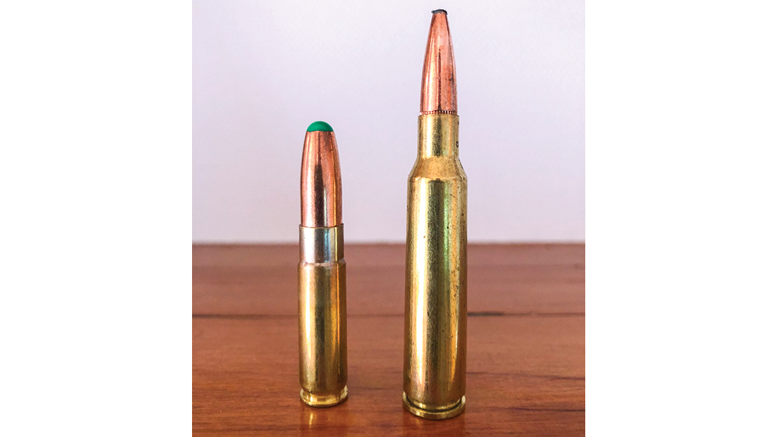
1/1
The .300 BLK is on the left next to the 6.5x55 Federal Fusion.

ACCURACY TESTING
The Howa performed well with all ammunition tested, but the star of the show was the Buffalo River ammunition – as illustrated by the image, the first three shots all keyholed. The average group size at 100m for the Buffalo River was 3/4 MOA. With the four kinds of ammunition trialled, the two that consistently produced sub-MOA groupings were the Buffalo River and the Nosler Match Grade. The Nosler SSA Subsonic also produced just on MOA.

FIELD TESTING

by Phil Caira
Due to a busy schedule and the Howa 1500 ending up in my gun safe, Dave asked me to take the rifle for a hunt and give some in-field feedback. I didn’t need to be asked twice! Any excuse to get out from behind the desk is welcome.
I decided to get my 8-year-old son, Luca, to have a shoot at the range as I was keen for him to try the .300 BLK calibre and its softer recoil; Luca consequently shot 15 rounds through it on the range. His only comment: “Dad, do you have any more ammo I can shoot? This is much more fun than your .308.” Priceless! I think it’s safe to say it got his tick of approval.
With Luca’s rifle range test done, I headed off to the Central Plateau for the hunt. The walk in was easy and I hardly noticed the weight of the rifle slung over my shoulder. Once I reached the thick bush, I found the shorter 16″ barrel plus suppressor made it a little easier to duck and dive under tree limbs than when carrying my own longer supressed .308.
In bush-stalking mode, I tend to carry the rifle cradled across my body rather than shoulder slung; I find from this position it requires less body movement and is easier to bring up to my shoulder if an opportunity arises for a shot. With heavier rifles, this can be tiring on the arms; with the Howa MiniAction, this wasn’t an issue.
One thing to be aware of when carrying the rifle in this way is the location of any mag releases – which on the Howa sits proud of the stock; on my own rifle, this is recessed and not something I usually have to be aware of.
By mid-morning, I’d reached some clearings – just as the sun was warming up the day. A few minutes later, I located a young fallow buck feeding in the bush edge. I ranged him at 195m and, given the fact I had some Nosler SSA 220gr Subsonic, I stalked to under 100m undetected. The Howa 1500 MiniAction made a nice quiet job chambering a 220gr; I then waited for a shot to present itself.
It was at this stage, the young buck started to feed into cover; not wanting to lose this opportunity, I carefully crawled sideways to get a better angle. The shot opportunity came, and the 220gr dropped him on the spot.
Just then, an unseen doe reacted to her friend dropping and ran out into the clearing. I cycled the bolt nice and quickly, ready for a second shot … but something didn’t feel quite right. It was then I noticed I’d somehow managed to catch the magazine release during my belly crawl and left the magazine a few metres away – bugger! That was a rookie mistake on my behalf.

FIELD TEST CONCLUSION
Howa MiniAction .300 BLK was nice and compact to carry whilst bush hunting with the shorter barrel snagging less on brush. Being supressed when using the subsonic rounds, it’s noticeably quieter, which is great if you’re running dogs or have opportunity for follow up shots at other animals.
The Nikko Sterling Panomax 3-9×40 scope with the .300 Blackout reticle has the option to be illuminated in either red or green; I personally like this option for lower light conditions. Although the bolt throw does get close to the scope when working the MiniAction, this is not such an issue for people with smaller hands.
This rifle would be a great starter for a younger hunter or those looking for a good bush hunting rifle. I know it’s on Luca’s want list!
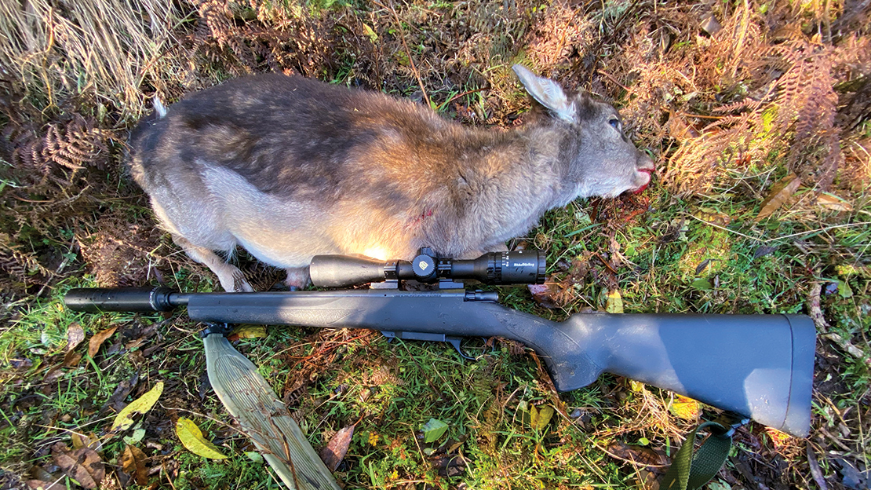
1/1
The young fallow buck taken with the SSA 220gr Subsonic ammo.

PROS & CONS
While out hunting, Phil experienced accidental magazine releases. The design of the Howa magazine release catch, being quite large and sitting proud from the magazine housing, can make it quite easy to knock or bump the catch if you’re not used to this design.
However, as a competition gun where a carbine is required that can hold 5 plus shots and enable quick magazine changes, this design is going to be a bonus. It’ll enable the competitor to become very slick and proficient at rapid magazine changes and this adds versatility to the rifle.
Due to the compact nature of the action and position of the bolt, a standard scope’s eye bell gets in the way of the bolt throw slightly – especially for those of you with hands like a bunch of bananas! It’s not so much a negative, but more a ‘be aware of’. A solution could be to use a holographic or compact quick-acquisition style scope/sight. Not only would this fix the issue, it’d make the Howa an awesome close- to mid-range carbine.
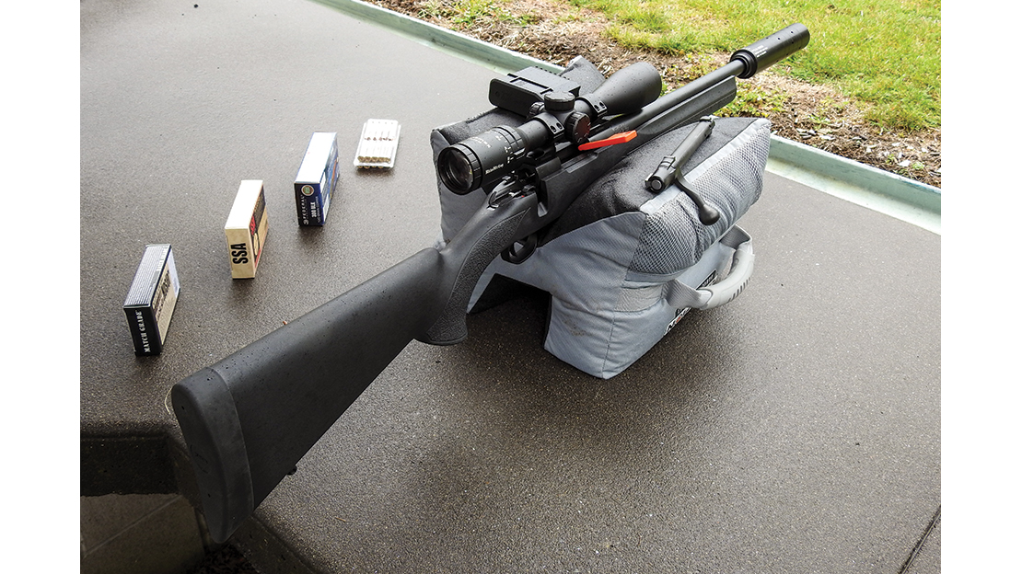
1/1
This rifle/calibre combo is an incredible amount of fun to fire!

SUMMARY
The Howa MiniAction has a lot going for it in terms of its user-friendly recoil, light weight, and short overall length and solid design.
It’s not a beautifully crafted rifle but more of a rugged and ready bush-style carbine. The .300 Blackout is a versatile calibre and a whole lot of fun; it’s suitable for the dedicated bush stalker who doesn’t need to take shots over 200m. It’s also great for introducing teenagers and beginners to shooting. The Howa would make a great pest-control rifle on animals like goats or just for a fun gun on the farm. Lastly, in competitions where a carbine would prove useful, the Howa with its 10-round magazine and quick magazine release would be ideal.
The only small grumble with the rifle is the design of the magazine release latch which sits proud at the front of the magazine housing. In a hunting scenario, this is something to be aware of depending on how you carry the rifle; however, in a competition or perhaps pest-control situation where quick magazine changes are required, this is a positive factor – it all depends on the application.
Overall, if you understand the capabilities and limitations of a calibre like the .300 BLK, the Howa MiniAction would make a fun addition to anyone’s collection.

